Collimator focus check with frange back focal length measuremnet

Ho-Lin Tsay, Hui-Jean Kuo, and Ming-Fu Chen
Taiwan Instrument Research Institute, National Applied Research Laboratories
Corresponding author: Ho-Lin Tsay, hltsay@narlabs.org.tw

ABSTRACT
Space-borne camera needs to be focusing. In laboratory, a collimator is usually used to simulate a distant object as target of camera to measure resolution, distortion and field of view. Whether focus position of collimator is correct affects the focus position of camera. Confirming focus position of the collimator is the preparatory work before the camera's whole test. This paper proposes a complementary method for confirming the focus position of collimator. Use telescope of camera to be tested as transfer target, measure flange back focus length in wavefront error measurement of this telescope, and then use collimator to project light to measure flange back focus length of same telescope. Comparing these two flange back focus length results, it can be concluded whether the collimator focus position is correct or not.

Keywords: Collimator, Telescope, Flange back focal length

INtroduction
Optical collimators were used in test of space-borne telescopes as well as cameras in laboratories to simulate target at several-hundred kilometres away. To perform visible and infrared test, most of these collimators were reflective.
Reflective collimator can be divided into two types: Reflective telescope projects collimating light with central obscuration and off-axis parabolic mirror projects collimating light with no central obscuration.
Self-collimation check is an optical qualitative inspection method. In this method, a collimated beam (parallel light) from a collimator was reflected back to the same system by a flat mirror. By adjusting the angle of reflection of the plane mirror, the reflection pattern can be placed side by side with the original pattern of the collimator. Comparing the pattern size on the same plane can qualitatively check the collimation of this collimator.
Another qualitative inspection method is to calibrate the collimator with another collimator. To perform this method, align the two collimators, and to project the collimated light with the calibrated collimator to adjust the focus to the collimator to be calibrated. Prerequisite is that the standard collimator should cover all of effective aperture for the piece to be calibrated.
A quantitative method to measure the collimation of the large-aperture collimator. This method calibrates the collimation of the collimator by measuring the relative angle with a moving theodolite[3].
We proposed a method by using flange back focal length of telescope as a reference to test collimation of collimator. This paper introduces measurement setup and measurement process.

setup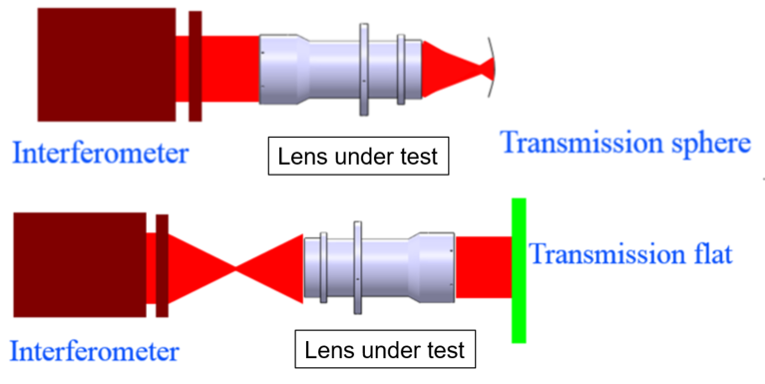
Fig. 1 Two schematic setup of lens/telescope wavefront error measurement.

Wavefront error measurements were performed with an interferometer with a tranmission sphere. Measuring setup was schematically showed in the lower part of Figure 1. A transmission flat was aligned to reflect measuring beam. This interferometer was equiped with a hexapod to measure position of auto-collimation as well as flange position.

Flange back focal length measurements was also performed with a collimator as a projector of target. and a moving microscope with 2D imaging sensor with coaxial light source to measure flange back focal length.

discussion
Measuring with an interferometer, optimal focus position and flange position were judged by the wavefront error results, and the accuracy can be less than 1 um. Measuring with a collimator, the effective focal length ratio between collimator and tested telescope is a decisive factor in the measurement accuracy. The square of the focal length ratio (vertical magnification) is the defocus amount ratio of collimator and tested telescope. If the focal length ratio is 3, the defocus ratio is 9, and if the mechanical back focus deviation of the telescope to be measured is measured to be 100 microns, then the defocus amount of the collimator is calculated to be 900 microns. The larger the effective focal length ratio, the smaller the defocus of tested telescope. By directly measuring with a telescope focus position, you can directly observe the offset caused by use of a collimator on the focus position of the telescope. If the measured offset is much smaller than the allowable value, this collimator should be qualified in testing telescope and focusing the corresponding camera.

conclusion
This paper proposes a method for measuring the collimation of a collimator by comparing flange back focal length of the telescope under test obtained by wavefront error measurement with that obtained by collimator measurement. Then, impact of the collimator defocus on telescope focus can be estimated. and z-axis position of the imaging sensor is decided.

References
[1]ISO 11421:1997,Optics and optical instruments -- Accuracy of optical transfer function (OTF) measurement.
[2] H. L. Tsay, Y. C. Lin , S. T. Chang and T. M. Huang, “Collimator focus check with interferometer” . SPIE 10373, Applied Optical Metrology II, 103730V (23 August 2017); doi:10.1117/12.2272105.
[3] Ho-Lin Tsay, Shenq-Tsong Chang, Yi-Hao Lin and Ming-Fu Chen,” Quantitative Collimation Measuring Method with Moving Theodolite”. AB 198 ACRS 2018.

How to Create a Production-Ready PDF File of Your Final Submission

ALL FONTS MUST BE EMBEDDED IN THE PDF FILE. THIS INCLUDES ALL FONTS CONTAINED IN THE GRAPHIC IMAGES AS WELL. THE PDF FILE MUST BE CREATED USING A PROGRAM SUPPORTED BY ADOBE ACROBAT. AND PLEASE MAKE SURE ALL IMAGES INCLUDED IN YOUR FINAL SUBMISSION.

How to Embed Fonts
You will be converting your source file to PDF for final submission to the proceedings. When creating the PDF file it is important to ensure that you embed all fonts. In order to ensure there is no loss if information in the PDF file, all fonts must be embedded. If your fonts are not embedded, your paper will not print correctly. Fonts should be embedded when creating the initial PDF file.

Converting Word to PDF
When creating a PDF file from a Word file the settings to embed the fonts should be done in Word. When printing to PDF from Word, the options are chosen when creating your print settings.
Below is how this should be done:
In the print dialog box
Select "Adobe PDF."
Select "Properties."
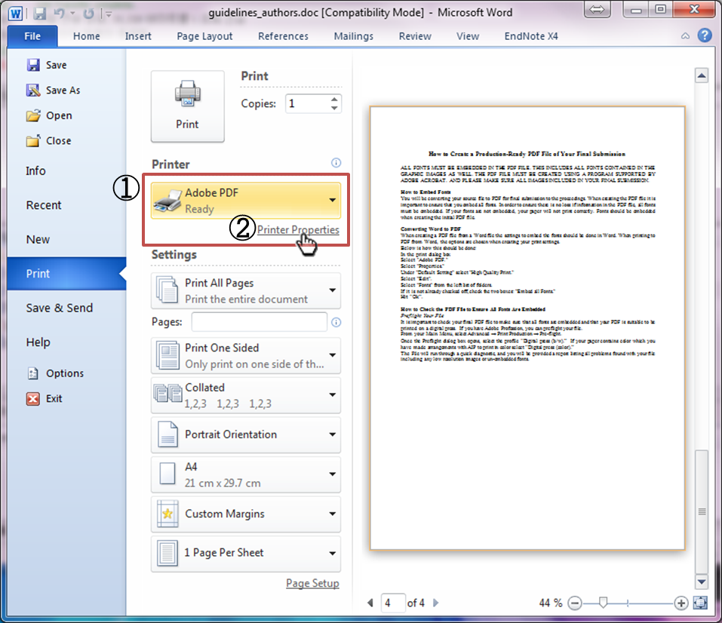
Under "Default Setting" select "High Quality Print."
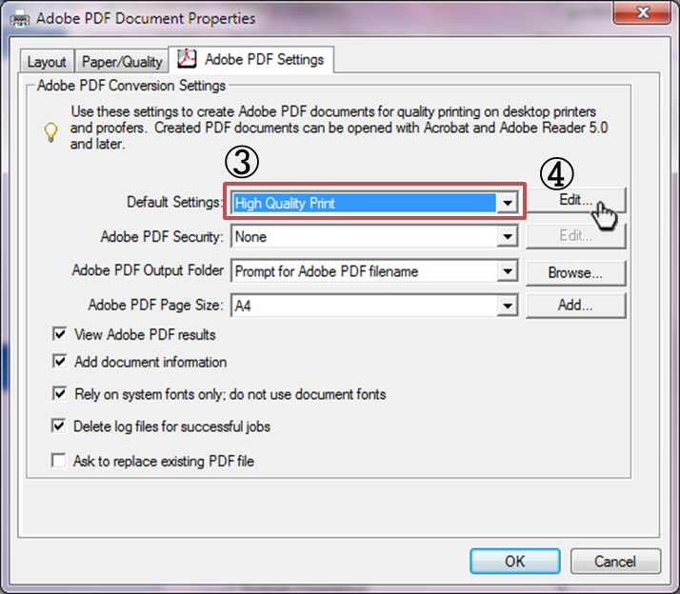
Select "Edit".
Select "Fonts" from the left list of folders.
If it is not already checked off, check the two boxes: "Embed all Fonts."
Hit “Ok”.
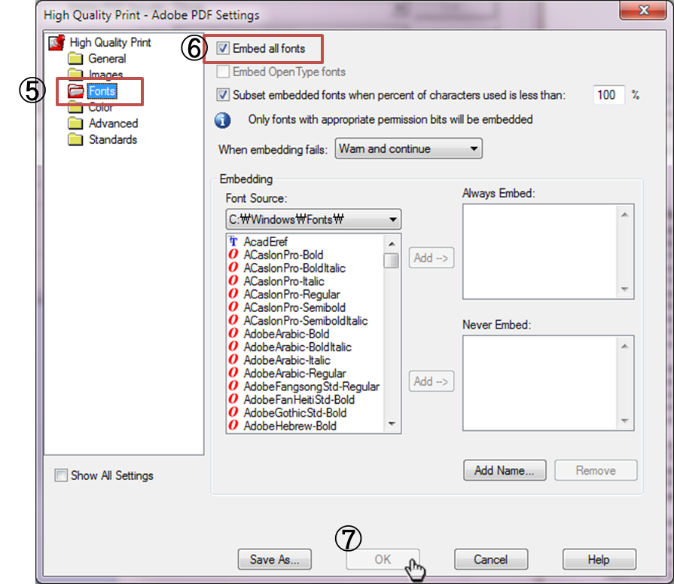

How to Check the PDF File to Ensure All Fonts Are Embedded
Preflight Your File
It is important to check your final PDF file to make sure that all fonts are embedded and that your PDF is suitable to be printed on a digital press. If you have Adobe Profession, you can preflight your file.
From your Main Menu, select Advanced → Print Production → Pre-flight.
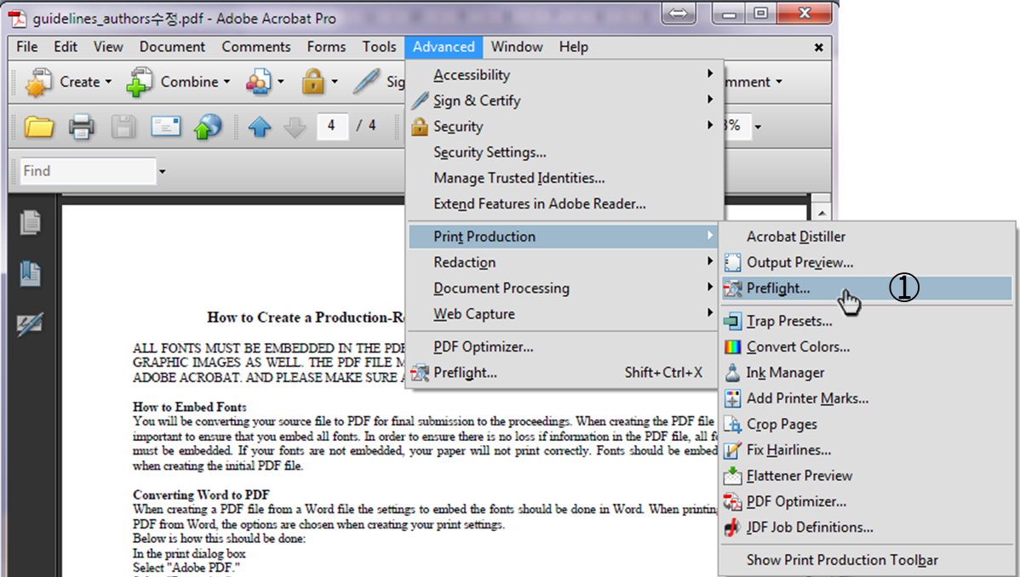
Once the Preflight dialog box opens, select the profile “Digital press (b/w).” If your paper contains color which you have made arrangements with AIP to print in color select “Digital press (color).”
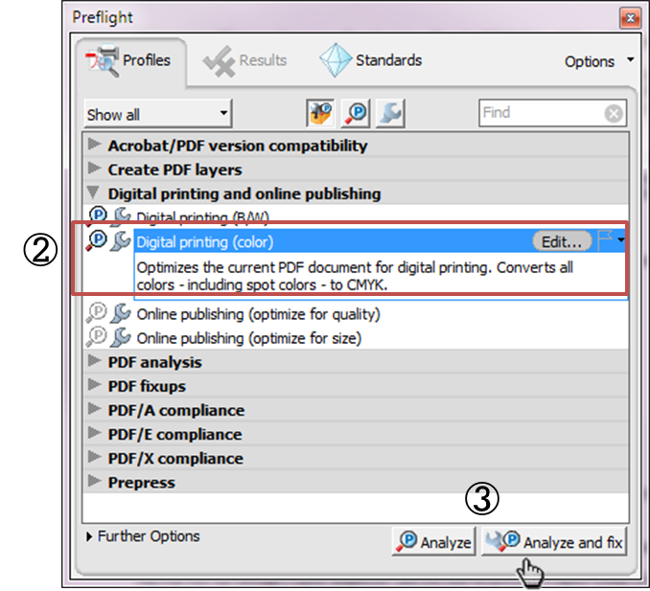
The File will run through a quick diagnostic, and you will be provided a report listing all problems found with your file including any low resolution images or un-embedded fonts.

